Lot 10

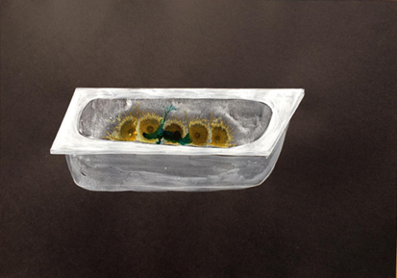
Nicolas Deshayes

Sunflowers

2018
signed in white ink on reverse lower left: Sunflowers, 2018/ Nicolas Deshayes
acrylic and ink on paper
29.7 x 42 cm
Copyright the artist

Courtesy Stuart Shave Modern Art

Estimate: £1,000-1,500

Sunflowers is a preliminary drawing which accompanies Nicolas Deshayes’ latest body of sculptures. Working primarily with various methods of industrial casting, Deshayes’ sculptures tend to be hard, made from material such as plastic, ceramic, vitreous enamel, aluminium or cast iron. Formally, however, his works reference soft, moving and malleable things; things that are alive and functioning. Recent works have operated as working metal radiators that pump water around a room, or water fountains in public ponds, while being formally suggestive of the interior of a body. Deshayes is concerned with turning the inside out. Plumbing systems that are usually hidden, both of the body – intestines, bowels - but also of the domestic and civic environment that carries its waste and keeps it clean, are central to his work.

Born in Nancy, France in 1983, Deshayes lives and works in London and Dover. He completed an MA in Sculpture at the Royal College of Art in 2009 and a BA in Sculpture at Chelsea College of Art and Design in 2005. Deshayes’ work has been the subject of solo exhibitions at Battersea Park’s Pleasure Gardens, Pumphouse Gallery, London (2018); Basement Roma, Rome, Italy (2018); Fonderia Artistica Battaglia, Milan, Italy (2016); Modern Art, London (2016); Glasgow Sculpture Studios, Glasgow (2015); Tate, St. Ives, Cornwall (2015); S1 Artspace, Sheffield (2013). His work has been included in group exhibitions at FRAC Grand Large, Dunkirk, France (2018); FRAC Ile de France, Chateau de Rentilly, Bussy-Saint-Martin, France (2018); Tate St Ives, Cornwall (2017); Drawing Room, London (2017); Inverleith House, Edinburgh (2016); Polish Institute, Berlin, Germany (2016); Eastside Projects, Birmingham (2016); Fridericianum, Kassel, Germany (2015); Leeds City Art Gallery, Leeds, U.K. (2015); Kestnergesellschaft, Hannover and David Roberts Art Foundation, London (2014).

Nicolas Deshayes, Swans, is on view at Modern Art Vyner Street until 16 February 2019.

