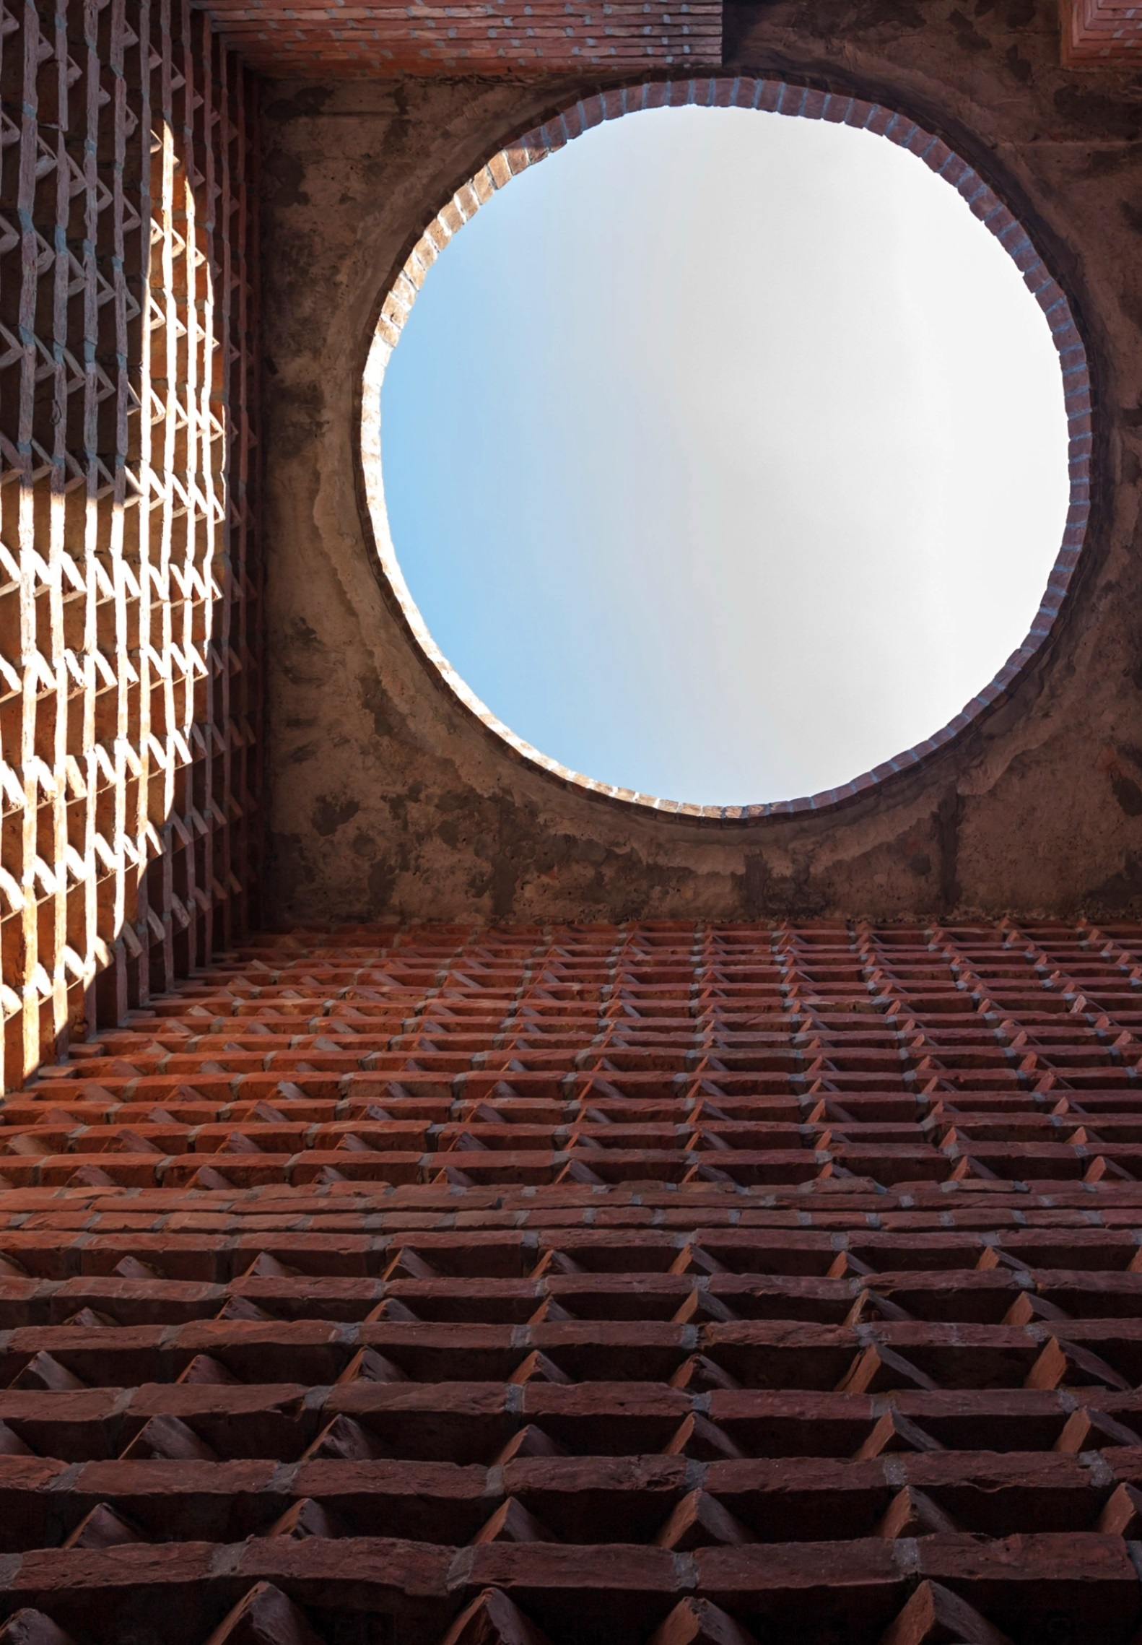
14 February – 12 May 2019
#IsThisTomorrow

Whitechapel Gallery
Is This Tomorrow?
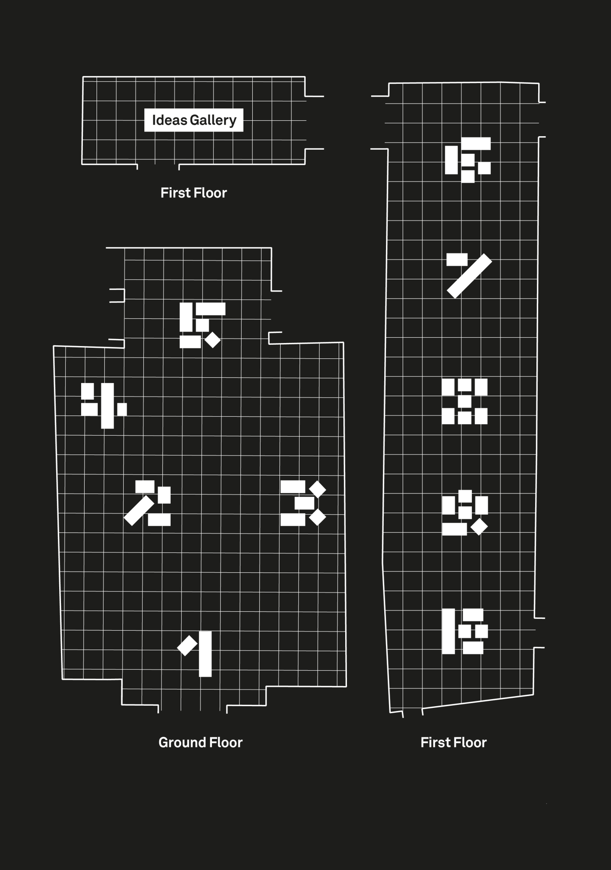

In an era when humanity is facing unprecedented
challenges posed by new technologies, bioengineering
and climate change, Whitechapel Gallery has invited
artists and architects to work collaboratively and offer
their visions of the future.

Is This Tomorrow? reimagines Whitechapel Gallery’s
landmark exhibition This Is Tomorrow (1956) for the
twenty-first century. The 1956 exhibition presented 37
British architects, painters and sculptors – including
Ernö Goldfinger, Richard Hamilton, Eduardo Paolozzi,
Victor Pasmore and Alison and Peter Smithson –
working together in small groups and, according to critic Lawrence Alloway, ‘setting a programme for the future’.

Is This Tomorrow? features experimental propositions
from leading architects and artists responding to
issues we face today. They have collaborated to imagine scenarios in which humans and other animals share the same spaces, queer desire and fracking meet on a mountainside; past cultural traditions provide future insights; grief and microbes generate new possibilities for housing.

Taking the form of environments, installations, models, structures and systems, and also incorporating artworks, objects, film and graphics, these projects are designed to be experienced.

1.

6a architects
Amalia Pica
Enclosure

6a architects, established in 2001, London, UK by Tom Emerson (b. 1970, France) and Stephanie McDonald (b. 1966, UK)

Amalia Pica (b. 1978, Argentina; lives in London)

Project Team: Tom Emerson, Stephanie McDonald, Amalia Pica and Owen Watson

Hurdles, pens, races, scales and feeding troughs
are just some of the equipment deployed in farming
industries to prescribe our relationship with animals
that often includes handling, transporting, commerce,
consumption, petting and even international diplomacy.

6a architects and artist Amalia Pica consider the physical connotations of animal architecture, creating a mazelike structure made from a sheep management system. Punctuating the installation are sculptures derived from animal-related objects, including buoys used to entertain captive seals, specially devised objects for pigs’ amusement, a cattle feeding bin and a hamster tunnel. In their research for the project, the group considered sources as diverse as a snakes and ladders board game, the eleventh-century Bayeux tapestry, animal illustrations on supermarket packaging and idioms and proverbs about animals.

Please speak to a gallery assistant if you would like to
enter the installation.

2.
Adjaye Associates
Kapwani Kiwanga
Sankofa Pavilion

Adjaye Associates, established in 2000, London, by Sir David Adjaye OBE (b. 1966, Tanzania) with offices also in New York and Accra

Kapwani Kiwanga (b. 1978, Canada; lives in Paris)

Project Team: Sir David Adjaye OBE, Kapwani Kiwanga and Duncan Wilson

Sankofa Pavilion is a star-shaped structure constructed from dichroic glass which selectively allows light to pass through, filtering out certain wavelengths to create an interplay of colours. Designed by architect Sir David Adjaye and artist Kapwani Kiwanga, the pavilion is a
space for intimate conversations; at once a place that
would allow for exchange and one that could register as a recording device. ‘Sankofa is an Ashanti word for reaching into the past to guide you into your future,’ says Adjaye. ‘As an architect, I was interested to see if we could work within a human tradition of people coming together, using some configuration of space as a device to debate futures or to debate pasts.’

The reflective properties of the glass allow for both
a degree of privacy and openness. Kiwanga has
complemented the pavilion with fabric which absorb the sound waves from conversations that take place within. Kiwanga notes, ‘research is being undertaken on fibres that will be able to both record and produce sound. The fabric, formed of woven strands, is already somehow imbued with a past. In the installation, it acts as a kind of witness to the gathering of people inside the pavilion.’

You are invited to take a seat inside the pavilion.

3.
APPARATA
Hardeep Pandhal
Thugz Mansion

APPARATA, established in 2015, London by Nicholas Lobo Brennan (b. 1983, UK), Astrid Smitham (b. 1983, UK) and Theo Thysiades (b. 1977, Greece)

Hardeep Pandhal (b.1985, UK; lives in Glasgow)

Project team: Oliver Choyce, Nicholas Lobo Brennan, Hardeep Pandhal and Astrid Smitham

What happens to architecture when political systems
collapse or become outmoded? APPARATA and Hardeep Pandhal present an installation that embodies the tension between stability and instability, permanence and improvisation.

‘Somewhere in between a construction site and a ruin’, their structure interacts with the floor, plaster walls and tall supporting columns that comprise the gallery’s architecture. A disk-shaped mirror is pushed against the gallery wall. Holding this in place, a large aluminium plane leans against a beam, supported by a thin metal cable and a prop. Underneath this provisional roof, stacked concrete blocks provide a resting place to listen to a song by Hardeep Pandhal. A comic cut-out of generic nuclear family references the scale figures that often appear in architectural renderings. Pandhal has made improvised drawings on the cut-out and its surroundings with a graffiti-like subversion of the hierarchies between the structure and its institutional framework.

You are invited to take a seat and listen to the music.

4.
Cao Fei
mono office
I want to be the future

Cao Fei (b. 1978, China; lives in Beijing)

mono office, established in 2018, Beijing by Pablo Alfonso Resa Abad (b. 1991, Spain), Miguel Esteban
Alonso (b. 1992, Spain) and Zhao Liqun (b. 1982, China)

Project team: Pablo Alfonso Resa Abad, Miguel Esteban Alonso, Cao Fei, Kit Huen and Zhao Liqun

The relationship between people and technology,
particularly how consumers adapt themselves and
their environments in a rapidly changing society,
are concerns shared by Beijing-based artist Cao Fei
and architects mono office. ‘For the huge development of its low-tech industries,’ they state, ‘China is often held as an architectural synecdoche of the future, a country symbolising a relationship between technology and the common people that is both seductive and uneasy. At best, such passion for technology drives the country’s creativity and economy, at worst it is symptomatic of a population withdrawing from the reality of modern China.’

Taking the form of an architectonic totem, I want to
be the future is a ‘machine’ composed of a set of
‘toolkits’ stacked on top of each other, reflecting our
uses, obsessions and adaptations of technology. Their
invention points to a future defined by the way in which people use technology and what new forms will appear as a result of this interaction.

5.

Andrés Jaque /
Office for Political Innovation
Jacolby Satterwhite
Spirits Roaming the Earth

Andrés Jaque / Office for Political Innovation, established in 2003, New York and Madrid by Andrés Jaque (b. 1971, Spain)

Jacolby Satterwhite (b. 1986, US; lives
in New York)

Project team: Juan David Barreto,
Roberto González García, Alberto
Heras, Andrés Jaque, Garazi Lara, Luis
González Martínez-Cabrera, Bansi
Mehta, Jesús Meseguer, Paola Pardo
and Jacolby Satterwhite

Taking its name from a house track recorded by Jacolby Satterwhite’s mother Patricia, Spirits Roaming the Earth, the work places human bodies in the context of resource extraction, ranging from DNA and shale minerals to highend real estate and the currency of queer desire.

The installation is a mountain-like structure with an
ambiguous surface encrusted with a plethora of everyday objects. The form opens up to reveal hidden structures – shaping actual and fictional forms of contemporary living – in which sex, designer babies, wealth, gentrification, queerness and fracking all converge in flickering moving images.

You are invited to enter the structure.

6.

Mariana Castillo Deball
Tatiana Bilbao Estudio
Mind Garden, Heart Garden

Mariana Castillo Deball (b. 1975, Mexico; lives in Berlin)

Tatiana Bilbao Estudio, established in 2004, Mexico City and Basel by Tatiana Bilbao (b. 1972, Mexico)

Project team: Tatiana Bilbao, Alba Cortes, Mariana Castillo Deball, Sophie de Saint Phalle and Paulina Sevilla

For Tatiana Bilbao and Mariana Castillo Deball, ‘to
measure – whether distance or time – is to develop
a material engagement with the world that is at once
emotional and conceptual.’

Deball’s sculptural work relating to the Mesoamerican
calendar, To¯nalpo¯hualli, is brought together with Bilbao’s architectural exploration of the human need to be isolated yet communally connected. Mind Garden, Heart
Garden reflects on our relation to time and how spaces are inhabited and can be designed for living based on conviviality and shared activities.

The perforated metal beams that intersect the structure correspond to the first page of the Codex Fejérváry-Mayer, a Pre-Hispanic codex from central Mexico that represents a To¯nalpo¯hualli or count of the days, a ritual calendar of 260 days formed by the combination of twenty names of days (veintenas) and thirteen numbers of days (trecenas). Each spatial coordinate refers to a colour: east – red, north – yellow, west – green and south – blue. The completed installation creates a space that corresponds to a year in the ritual calendar.

You are invited to enter the installation.

7.

Rana Begum
Marina Tabassum Architects
Phoenix Will Rise

Rana Begum (b. 1977, Bangladesh; lives in London)

Marina Tabassum Architects, established in 2005, Dhaka, by Marina Tabassum (b. 1969, Bangladesh)

A simple, white facade – composed of a rectangular
base supporting an inverted trapezoid – conceals
what lies within. Like Marina Tabassum’s Bait Ur Rouf
Mosque, a humble brick building designed as a refuge for meditation and prayer in a crowded Dhaka neighborhood, this structure also reveals its spiritual aspect once you enter the space. Here, the architect creates another environment infiltrated by natural light from an overhead oculus. Inside, light plays off the beautifully faceted and pigmented surface created by Rana Begum.

Informed by the architect’s and artist’s shared interests in geometry, material and spatial concerns and the specificity of cultures, Phoenix Will Rise offers light, hope and a space of spiritual reflection. The title fittingly refers to the mythological bird associated with the sun, which is a symbol for renewal.

You are invited to enter the structure.

8.

David Kohn Architects
Simon Fujiwara
The Salvator Mundi Experience

David Kohn Architects, established in 2007, London by David Kohn (b. 1972, UK)
Simon Fujiwara (b. 1982, UK; lives in Berlin)

Project team: Mungo Adam-Smith, Maria Bartau Madariaga, Elva Choi, Simon Fujiwara, David Kohn, Jessica Lyons and Bushra Mohamed

Artist Simon Fujiwara and architect David Kohn present a miniature museum offering the opportunity to experience Leonardo da Vinci’s Salvator Mundi, which broke records for the highest price paid for an artwork at auction. An ingenious marketing campaign transformed the painting into one of the most mediated images in the world.

Their investigation led them to Abu Dhabi and the new
Louvre museum where Salvator Mundi was due to be
displayed. En route, they visited other mass attraction
experiences including Dubai’s Burj al Khalifa, the world’s tallest building, and Ferrari World, a theme park devoted to speed. Fujiwara and Kohn began to see the possibility of their roles as artist and architect becoming obsolete in the face of the undeniable immersive appeal of these ‘content-easy’ spectacles.
Housed in a model building composed entirely of sampled architecture and devoted to a ‘masterpiece’ that only appears as a replica or projection, The Salvator Mundi Experience explores the plausible proposition of a world ‘post-art’, ‘post-architecture,’ even ‘post-culture’ as we know it.

One visitor at a time may enter the model. Please speak to a gallery assistant if you require assistance.

9.

Farshid Moussavi Architecture
Zineb Sedira
Borders / Inclusivity

Farshid Moussavi Architecture, established in 2011, London, by Farshid Moussavi OBE RA (b. 1965,
Iran; lives in London)

Zineb Sedira (b. 1963, France; lives in London)

Project team: Farshid Moussavi, Zsuzsa Peter and Zineb Sedira

Attempts to block free movement of people, goods and information have become a new reality across the world. Borders between nation states and between public and private zones have witnessed recent contestations. As Farshid Moussavi and Zineb Sedira state, ‘borders block free movement but cannot create homogeneous societies. Diversity of ideas, people and things exists at a molecular scale in every city.’

Moussavi and Sedira have installed a group of nine
turnstyles – some of which rotate in a single direction
and others that are bi-directional. Revolving barriers and gates are often used for security and to control access in stadiums, transport systems, construction sites, amusement parks, businesses and industrial facilities. Invited to navigate through the turnstyles, visitors trigger motion sensors, which activate a variety of recorded sounds – electronic, mechanical and natural – including alarms, birds chirping and water flowing.

Please speak to a gallery assistant if you would like to
enter the installation.

10.

Rachel Armstrong
Cécile B. Evans
999 years, 13sqm (the future belongs to ghosts)

Rachel Armstrong (b. 1966, UK; lives in Newcastle)
Cécile B. Evans (b. 1983, US; lives London)

A list of materials, participants and credits is available in the exhibition

Professor of Experimental Architecture Rachel Armstrong and artist Cécile B. Evans present 999 years, 13sqm (the future belongs to ghosts) as an exploration of the parameters of a dead future, that is, a future defined by the failures of the past. Prevailing units of measurement and capital, here the 13sqm defined as the smallest official living space in London or the 999 years listed on the longest leasehold agreements in the UK, often fail to align with the reality of lived experiences. Armstrong and Evans suggest it’s the ‘uncooperative matter’, entities
such as emotions or microbes that could lead to fluid,
unfixed perceptions of multiple realities: something more aligned with the uncertainty of human experience.

The structure acts as a living and dying organism,
prioritising the material realities of change over its
coordinates. A figure appears in a curtain of fog, its
atomised particles partially collected by dehumidifiers. A colony of microbes inhabits a microbial fuel cell (MFC) bioreactor brick installation, generating energy to power an electronic display. Finally, a text shaped by conversations around the project quietly unfolds as the structure evolves.

You are invited to view the installation from outside.
Please do not touch the structure or step onto the tiles.

Exhibition catalogue:
Is This Tomorrow?
Special Exhibition Price: £20

Is This Tomorrow? Lates
Every Thursday and Friday
from 6pm

Curator’s Tours
Friday 15 March, 22 March,
5 April, 12 April, 6.30pm
Free, booking required

Events:
Big Ideas: Tatiana Bilbao
Talk
Thursday 14 February, 7pm
£9.50/£7.50 concs

Tomorrow, Today: Art,
Architecture and the Future
Symposium
Friday 15 February, 11.30am – 6pm
£15/£12.30 concs

Audio Description Tours
Sunday 17 March, 18 April,
11.30am
Free, booking required
British Sign Language Tour
Thursday 21 March, 6pm
Free, booking required

Co-Commissioned with

Supported by:

The Whitechapel Gallery
Commissioning Council:
Erin Bell, Leili Huth, Irene Panagopoulos,
Catherine Petitgas, Mariela Pissioti,
Alex Sainsbury

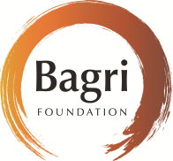

The Ford Foundation
Living Architecture
Personal Improvement Ltd
Walmer Yard

The Embassy of the Argentine Republic
in the United Kingdom, The High
Commission of Canada to the United
Kingdom, The Embassy of Mexico in
the United Kingdom, The Embassy of
Spain in the United Kingdom

Shelley Fox Aarons and Philip Aarons,
Mr Gabriel Calparsoro, Collezione
Nunzia and Vittorio Gaddi, Euroboden
Architekturkultur, Yasuharu Ishikawa,
Nobuhiro Nishitakatsuji, Katsumi
Nozawa

Artwork Insurance Partner: Hiscox

Cover: Marina Tabassum
Bait Ur Rouf Mosque, 2012
Photo Credit: Hasan Saifuddin

Please return this booklet to the Information Desk.

