September’s Walking Tour begins at Whitechapel Gallery with an opportunity to see free displays: Eileen Simpson and Ben White (Open Music Archive): Once Heard Before, Sense Sound/ Sound Sense: Fluxus Music, Scores & Records in the Luigi Bonotto Collection, Artists’ Film International and the London Art Book Fair.

Next stop is a 15 minute walk to Studio 1.1 to view Store / Room; a major show displaying works the studio has accumulated over the years. Second stop is St. John on Bethnal Green (18 mins) where an immersive display of art, music, projections and workshops entitled NOT my Planet will raise questions about our environment and highlight the urgent climate crisis. Be sure to ask a member of staff for a welcome pack including free merchandise from exhibiting artists. Finally, head to IMT Gallery (6 mins) for Benedict Drew’s solo show Trapped in a sticky shed with side chain compression. Drew works across video, sculpture and music, creating large-scale multimedia installations which comment on the effects of socio-political and environmental issues.
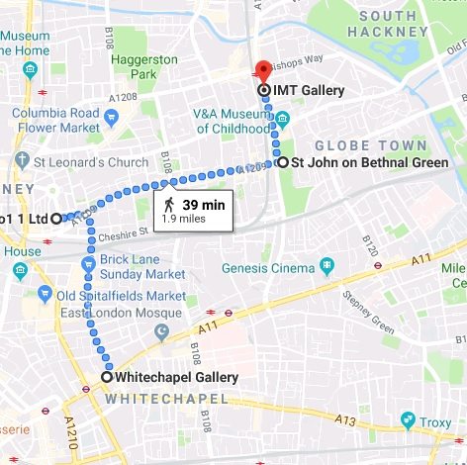
- Studio 1.1
Store / Room
57A Redchurch Street
E2 7DJ
@studio1.1_london

- St. John on Bethnal Green
Not my Planet
200 Cambridge Heath Rd
E2 9PA

- IMT Gallery
Trapped in a sticky shed with side chain compression
Unit 2/210 Cambridge Heath Road
E2 9NQ
@imtgallery

