Large Print Guide
Carlos Bunga: Something Necessary and Useful
21 January– 6 September 2020


Gallery 2
Please return

This document includes large print of all the wall labels found within Carlos Bunga: Something Necessary and Useful.

The document begins with the first wall labels at the front of Gallery 2, which provide an overview of the exhibition. This document then continues with the labels found in the link-space at the back of Gallery 2, and then with the labels found both at the bottom and the top of the library stairs.

This document is illustrated for clarity.

Continues on next page.
Carlos Bunga:
Something Necessary and Useful

‘Walking around the gallery, we have this experience of
temporality between past and future. What links both is our presence, our body and its relation to the space.’
Carlos Bunga

For his first UK commission, Carlos Bunga (b. 1976, Portugal) creates monumental structures, proposing a transitory and corporeal architecture made of everyday materials.

Bunga makes cardboard constructions and repurposes
domestic furnishings, building an evolving installation in
dialogue with the historic interiors of the gallery. The artist encourages us to get lost in the painted surfaces and openings, to wander among items of adapted furniture, and to gaze up at large textured canvases.
Drawing on his own experience of displacement, Bunga’s works often recall theatre sets, architectural models, as well as temporary shelters.
Continues on next page.
For this commission he is also inspired
by the nineteenth-century American Shaker movement, which originated in England in the 1750s. Their egalitarian ideals and advocacy of simplicity and beauty prompts Bunga to explore what is ‘necessary and useful’ in art, architecture and design.

Through its course, the installation will change as it is cut by its maker, reconfigured and then destroyed. Bunga also invites the choreographer Joe Moran and dancers to perform in the gallery, exploring their shared interest in the relationship among bodies, physical space and time in a series of live events.

Please check our website for details of live performances. The exhibition is accompanied by an illustrated catalogue and a series of limited edition prints.

Continues on next page.
Carlos Bunga: Something Necessary and Useful

This commission has been generously supported by:
The Whitechapel Gallery Commissioning Council: Dorota Audemars, Erin Bell, Heloisa Genish, Leili Huth, Irene Panagopoulos, Catherine Petitgas, Mariela Pissioti, Alex Sainsbury

The Carlos Bunga Exhibition Circle:
Galería Elba Benítez
Nicoletta Fiorucci Russo (Founder, Fiorucci Art Trust)
Alejandro Lazaro
Gonzalo Parodi

With additional support from:
AC/E Acción Cultural Española
Fundaçáo Calouste Gulbenkian
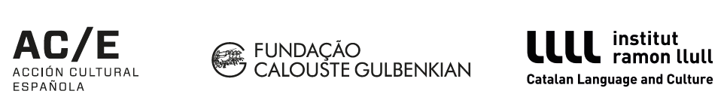
institut ramon llull Catalan Language and Culture
Continues on next page.
Carlos Bunga

Ghosts #1-5, 2019

Acrylic on chromogenic colour print

In the series of images Ghosts #1-5 (2019) Carlos Bunga intervenes on historic images of the Whitechapel Public Library. Gallery 2 was the former reading room of the Library before its relocation in 2005. The images are taken in the 1930s when the room featured high level bookcases, which were rearranged in the 1960s to make way for a central loans desk. Through his intervention with vivid paints, Bunga draws brings colour to the black and white images, creating a link with the present moment and his painted installation in the gallery space.

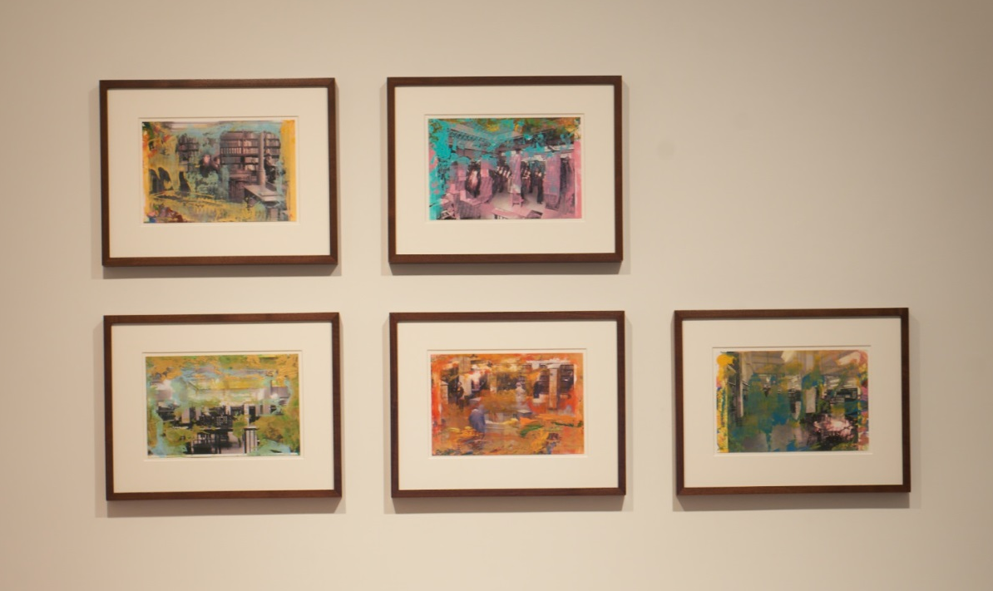
Image Description: Ghosts #1-5, 2019
Five framed works, slightly smaller thank A4 size. The images within the frames show black and white photographs of the Whitechapel Library (now part of the Whitechapel Gallery). The photographs have been roughly painted over with bright colours, adding texture and vibrancy to the monochromatic photographs beneath.

Continues on next page.
Carlos Bunga

Intersection Series #18, 2019

Acrylic on cardboard

Continues on next page.
Carlos Bunga

Behind, 2000

Single-channel video, colour, sound, loop
01:24 mins

Behind (2000) is an early performance work by Carlos Bunga created whilst he was studying painting at the Escola Superior de Arte e Design in Caldas da Rainha in Portugal (1998-2000). It marks a departure for the artist from working in two-dimensional form on canvas, breaking through it to consider the relationship between painting and physical space and developing site-specific installations. In this work Bunga refers to Barnett Newman’s ‘zip’ paintings, he undoes a canvas’s zip in order to explore the space behind it and to enclose himself within it.

Continues on next page.
Carlos Bunga

Polychromatic Environment, 2020

Mixed Media

This site-specific installation is comprised in a variety of suspended everyday fabrics and moving blankets by Carlos Bunga (b.1976, Portugal) which complements his new commission for Gallery 2.

Originally trained as a painter, his work developed to explore painting’s three-dimensionality: paint as a physical material, how it cracks and transforms according to its support, and how it can be hung in different configurations like a sculpture in space. Bunga encourages the viewers to experience the work from different viewpoints in the foyer and up the staircase.

Continues on next page.
Carlos Bunga

Untitled, 2020

Shaker chair

End of document.

