Tuesday 4 August 2020
Autumn 2020 Programme Announcement

Whitechapel Gallery’s entirely free autumn 2020 exhibition season celebrates diversity in ideas, medium and practice through new artist commissions, retrospectives, archival material and international collection displays.

COMMISSION
Nalini Malani: Can You Hear Me?
23 September 2020 – May 2021
Gallery 2
Free Entry
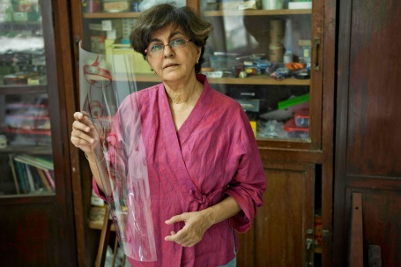
Whitechapel Gallery unveils a major new work titled Can You Hear Me? by Nalini Malani (b. 1946 Karachi, Undivided India; lives and works in Mumbai, India) as part of its prestigious annual programme of artist commissions.

Embodying the role of the artist as social activist, Malani gives voice to the marginalised through visual stories which often take the form of multi-layered, immersive installations, exploring themes of violence, feminism, politics, racial tensions and social inequality. Widely considered the pioneer of video art in India, Malani has a 50-year multimedia practice that includes film, photography, painting, wall drawing, erasure performance, theatre, animation and video.

Can You Hear Me?, the artist’s first UK commission, comprises 84 animations projected on the walls of the Whitechapel Gallery’s historic interior. Made between 2017 and 2020, they feature overlapping hand-drawn images and notes, as well as fragments of quoted text. In this installation Malani once more fills the former central reading room of the Whitechapel Public Library with books, transcribing quotes by influential writers such as Hannah Arendt, James Baldwin, Bertolt Brecht, Veena Das, Faiz Ahmad Faiz, Milan Kundera, George Orwell and Wislawa Szymborska. This 21st century form of the artist notebook is projected directly onto the gallery’s brick walls with text and image taking the form of moving graffiti.

Curated by Emily Butler, Mahera and Mohammad Abu Ghazaleh Curator, Whitechapel Gallery, with Inês Costa, Curatorial Assistant, Whitechapel Gallery.

Accompanied by a fully-illustrated catalogue.
Supported by Whitechapel Gallery Commissioning Council: Dorota Audemars, Erin Bell, Heloisa Genish, Leili Huth, Irene Panagopoulos, Catherine Petitgas, Mariela Pissioti, Alex Sainsbury

MAJOR EXHIBITION
Kai Althoff goes with Bernard Leach
7 October 2020 – 10 January 2021
Galleries 1, 8 & 9
Free Entry
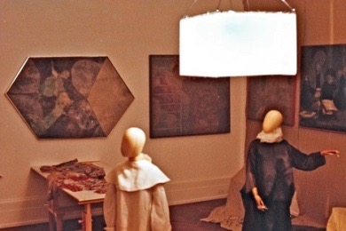
Whitechapel Gallery presents the first major UK survey of figurative painter and creator of poetic mise-en-scenes, Kai Althoff (b. 1966 Cologne, Germany; lives and works in New York, USA and Cologne, Germany). The exhibition brings together more than 130 works spanning Althoff’s career, from childhood drawings and photographs to textiles, sculptural installations and new paintings, presented as part of three immersive environments. Read a description of the exhibition from the artist here.

Althoff draws on a wide range of literary, cultural and artistic influences in his work and, for this exhibition at the Whitechapel Gallery, he pays tribute to British potter Bernard Leach (1887–1979). The exhibition features over 30 of Leach’s ceramic vessels and tiles from the 1920s onwards, selected by Althoff from UK collections and displayed in vitrines designed by the artist. The exhibition takes place in the centenary year of the Leach Pottery in St Ives, founded in 1920 and considered the birthplace of British studio pottery.

Curated by Emily Butler, Mahera and Mohammad Abu Ghazaleh Curator, Whitechapel Gallery with Cameron Foote, Assistant Curator, Whitechapel Gallery.

Accompanied by a fully-illustrated catalogue including installation photography by Kai Althoff.

ARCHIVE
Exercising Freedom: Encounters with Art, Artists and Communities
7 October 2020 – 21 March 2021
Gallery 4
Free entry
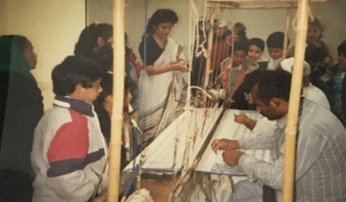
By the mid-1970s the cultural mosaic of East London changed significantly as local artists found themselves living and working alongside local communities, who provided an invigorating environment rich in ideas, possibilities and resources. This archive exhibition focuses on the Whitechapel Gallery’s community education programme from 1979 to 1989, exploring the role that art plays in society. The display highlights how artists play a part in developing participatory and educational activities and features interviews with key figures, whose involvement helped to cement the Gallery’s pioneering ethos and vision in art and education, including Zarina Bhimji (b. 1963, Mbarara, Uganda), Fran Cottell (b. Kent, UK), Charlie Hooker (b. 1953, London, UK), Denise Jones, Rob Kessler (b. 1951, Solihull, UK) and Jenni Lomax, Community Education Organiser at the time.

Documents, pamphlets, posters, photographs, tape slides, film and audio recordings drawn from the gallery’s extensive archive will be presented for the first time to the public, alongside material from personal archives.

Co-curated by Jenni Lomax, Director, Camden Arts Centre, 1990-2017; Sofia Victorino, Director of Education and Public Programmes, Whitechapel Gallery and Nayia Yiakoumaki, Head of Curatorial Studies, Whitechapel Gallery.

COLLECTION
Accelerate your escape: Gary Hume explores the Hiscox Collection
25 August 2020 - 3 January 2021
Gallery 7
Free Entry
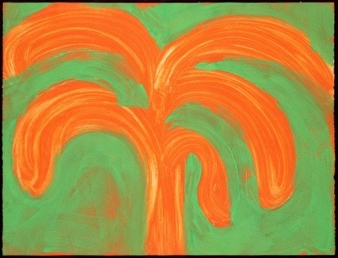
Important works by renowned artists including Etel Adnan (b.1925, Beirut, Lebanon), Nan Goldin (b.1953, Washington D.C, USA), David Hockney (b.1937, Bradford, UK), Noemie Goudal (b. 1984, Paris, France), Prem Sahib (b. 1982, London, UK), Joan Miró (1893-1983, Spain), Eduardo Paolozzi (1924-2005, UK) and Pablo Picasso (1881-1973, Spain), are on public view for the first time in two consecutive, artist-curated exhibitions drawn from the Hiscox Collection, taking place at Whitechapel Gallery. The series forms part of the Gallery’s ongoing commitment to showing rarely seen public and private collections.

Global insurer Hiscox have been collecting modern and contemporary art for over 50 years. The collection comprises 1000 works by renowned artists, including Grayson Perry, Tacita Dean and Peter Doig. With no single work ever in storage, this living collection is displayed across the company’s 35 global offices – on the walls of common areas and meeting rooms, enlivening the working environment with art that provokes thought or sparks creativity.

British painter Gary Hume (b.1962, Tenterden, UK) and Berlin-based Venezualan artist Sol Calero (b.1982, Caracas, Venezuela) each bring new perspectives to the Hiscox Collection in their personal selection of works at Whitechapel Gallery. For Hume, making and viewing art are a means of escape. Hume invites us to escape the every day and to find new joys and sorrows in the myriad worlds imagined for us by the artists he has selected. Sol Calero’s selection will launch in January 2021.

Curated by Laura Smith, Curator, Whitechapel Gallery with Grace Storey, Assistant Curator, Whitechapel Gallery.

Accompanied by a fully-illustrated catalogue.

PROJECT
Duchamp & Sons selects from the Hiscox collection
25 August 2020 - 3 January 2021
Galleries 5&6
Free Entry

Considering the ways in which lockdown has affected experiences of art and culture, Whitechapel Gallery’s Youth Forum, Duchamp & Sons, presents a virtually curated display featuring artworks drawn from the Hiscox Collection.

What role might art play when our freedom is interrupted? What does it mean to curate from our laptops and screens? Can confinement trigger new creative processes and networks of solidarity?

In searching for ways to stay connected, the Youth Forum’s display explores ideas of home and asks what makes a community.

Curated by Duchamp & Sons with Renee Odjidja, Swarovski Foundation Curator for Youth and Community Programmes, Whitechapel Gallery and Sofia Victorino, Director of Education and Public Programmes, Whitechapel Gallery.

WRITER IN RESIDENCE 2020
Himali Singh Soin

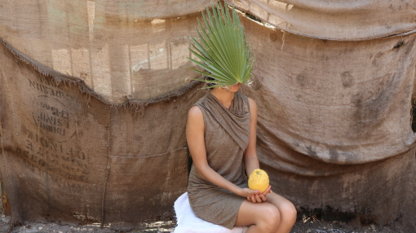
As Whitechapel Gallery Writer in Residence for 2020, Himali Singh Soin (b. 1987, Delhi, India) creates a new series of poetic texts drawing on research into her namesake, the Himalayas, its animistic rituals and remedies and mystical geometries. Collectively titled ancestors of the blue moon, the collection of 13 ‘flash fictions’ are written from the perspective of remote or forgotten deities and delivered digitally from the artist’s home in Delhi. A live multi-media performance with the collective Hylozoic/Desires will mark the culmination of her residency in 2021.

Notes to editors

About Whitechapel Gallery

For over a century the Whitechapel Gallery has premiered world-class artists from modern masters such as Pablo Picasso, Jackson Pollock, Mark Rothko, Frida Kahlo and Hannah Höch to contemporaries such as Zarina Bhimji, Sophie Calle, William Kentridge, Eduardo Paolozzi and Michael Rakowitz. Its historic campus houses exhibitions, artist commissions, collection displays, historic archives, education resources, inspiring art courses, talks and film screenings, the Townsend dining room and the Koenig Bookshop. It is a touchstone for contemporary art internationally, plays a central role in London’s cultural landscape and is pivotal to the continued growth of the world’s most vibrant contemporary art quarter.

Visitor Information

Admission: Free
Opening times: Tuesday – Sunday, 11am – 6pm; Thursdays, 11am – 9pm
Whitechapel Gallery, 77 – 82 Whitechapel High Street, London E1 7QX
Nearest London Underground Stations: Aldgate East, Liverpool Street, Tower Gateway DLR
T + 44 (0) 20 7522 7888 | E info@whitechapelgallery.org | W whitechapelgallery.org

Press Contact

For more information, interviews and images, contact:

Carrie Rees at Rees & Co | carrie@reesandco.com
Jenny Lea | jennylea@whitechapelgallery.org
Megan Miller | meganmiller@whitechapelgallery.org |press@whitechapelgallery.org

