List of objects proposed for protection under Part 6 of the Tribunals, Courts and Enforcement Act 2007 (protection of cultural objects on loan).

The following works are proposed to be covered by Immunity from Seizure - from the collection of MoMA, The Museum of Modern Art, New York.

Cecilia Vicuña (Title TBC)
Whitechapel Gallery
6 October 2026 – 14 February 2027
Galleries 1, 2 and 3

MoMA, The Museum of Modern Art, New York.
11 West 53 Street, New York, NY 10019
USA
https://www.moma.org/

Whitechapel Gallery
77-82 Whitechapel High Street
London E1 7QX
United Kingdom
T: +44 (0) 20 7522 7888
www.whitechapelgallery.org

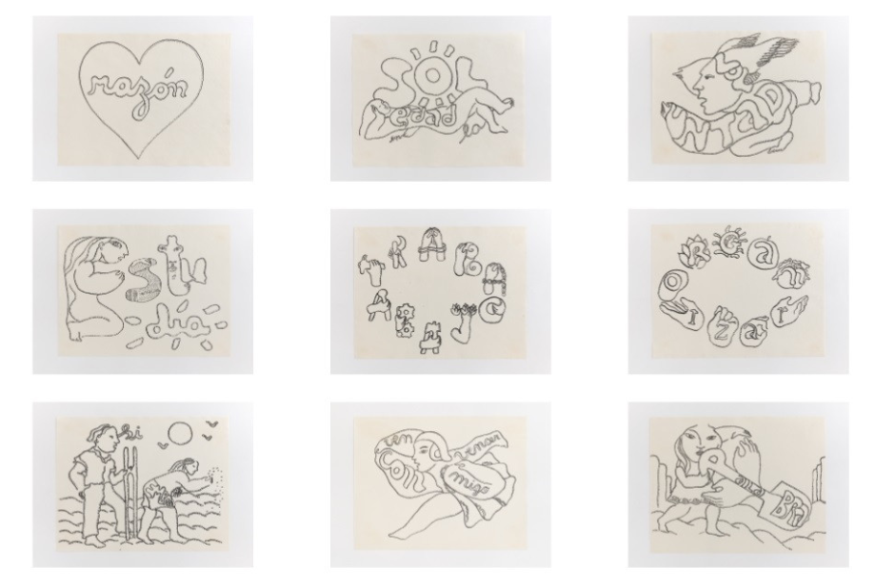

Cecilia Vicuña
born 1948, Chile
AMAzone Palabrarmas, 1978
Series of twenty-eight drawings in ink and pencil on paper
Each: 8 1/2 × 11" (21.6 × 27.9 cm)
The Museum of Modern Art, New York. Latin American and Caribbean Fund, Modern Women's Fund, gift of Agnes Gund, Amalia Amoedo, María Luisa Ferré Rangel (in honor of Cyril Meduña) and Juan Yarur Torres (in honor of Amalia Amoedo), 2021

Provenance:
The artist
Lehmann Maupin Gallery, New York
2021 - present, The Museum of Modern Art, New York. Purchased from the above

Lender: The Museum of Modern Art, New York
Inventory no.: 384.2021.1-28
Created: Bogotá, Colombia

Brief description: Series of twenty-eight drawings in ink and pencil on paper

