List of objects proposed for protection under Part 6 of the Tribunals, Courts and Enforcement Act 2007 (protection of cultural objects on loan).

The following works are proposed to be covered by Immunity from Seizure - from the collection of The Art Institute of Chicago, Chicago, IL.

Nicole Eisenman: What Happened
Whitechapel Gallery
10 October 2023 – 14 January 2024
Galleries 1, 8 and 9

The Art Institute of Chicago
111 South Michigan Avenue
IL 60603 Chicago
USA
https://www.artic.edu/

Whitechapel Gallery
77-82 Whitechapel High Street
London E1 7QX
United Kingdom
T: +44 (0) 20 7522 7888
www.whitechapelgallery.org

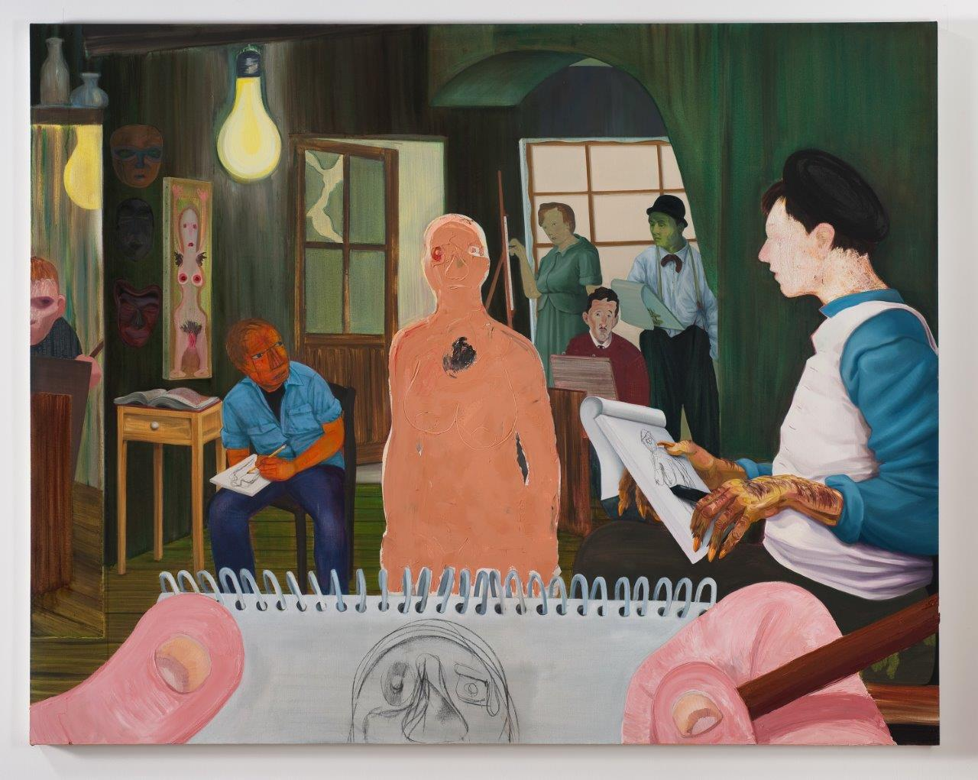

Nicole Eisenman
born 1965, USA

The Drawing Class
2011
Oil and charcoal on canvas
165.1 x 208.3 cm

Lender: The Art Institute of Chicago
Inventory no.: 2011.298
Created: New York
Image: Courtesy the artist and Vielmetter Los Angeles. Photo: Robert Wedemeyer © Nicole Eisenman

Provenance: Acquired by Society for Contemporary Art for The Art Institute of Chicago in 2011
The Drawing Class - SCA (scaaic.org)

Brief description: Oil on canvas painting of a drawing class

Ownership between 1933-1945: NA

List of objects proposed for protection under Part 6 of the Tribunals, Courts and Enforcement Act 2007 (protection of cultural objects on loan).

The following works are proposed to be covered by Immunity from Seizure - from the collection of Martin and Rebecca Eisenberg.

Nicole Eisenman: What Happened
Whitechapel Gallery
10 October 2023 – 14 January 2024
Galleries 1, 8 and 9

Martin Eisenberg
c/o Rockdale Capital
955 South Springfield Ave, Bldg. A, Suite 101
Springfield, NJ 07081
Whitechapel Gallery
77-82 Whitechapel High Street
London E1 7QX
United Kingdom
T: +44 (0) 20 7522 7888
www.whitechapelgallery.org

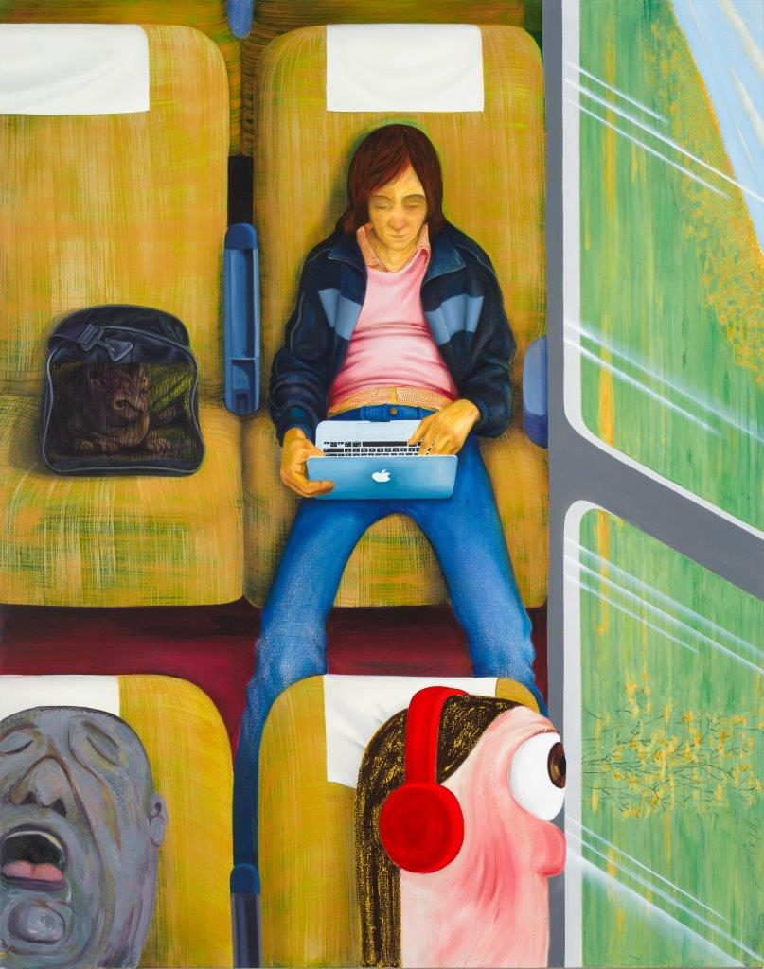

Nicole Eisenman
born 1965, USA

Weeks on the Train
2015
Oil on canvas
208.3 x 165.1 cm

Lender: Martin and Rebecca Eisenberg
Image: Courtesy the artist and Anton Kern Gallery, New York © Nicole Eisenman
Created: New York

Provenance: Acquired from Anton Kern Gallery in 2015
Nicole Eisenman, Weeks on the Train, 2015 | Anton Kern Gallery

Brief description: Oil on canvas painting of figures on a train

Ownership between 1933-1945: NA

List of objects proposed for protection under Part 6 of the Tribunals, Courts and Enforcement Act 2007 (protection of cultural objects on loan).

The following works are proposed to be covered by Immunity from Seizure - from the collection of The Jewish Museum, New York.

Nicole Eisenman: What Happened
Whitechapel Gallery
10 October 2023 – 14 January 2024
Galleries 1, 8 and 9

The Jewish Museum, New York
1109 5th Ave at 92nd St
New York, NY 10128
https://thejewishmuseum.org

Whitechapel Gallery
77-82 Whitechapel High Street
London E1 7QX
United Kingdom
T: +44 (0) 20 7522 7888
www.whitechapelgallery.org

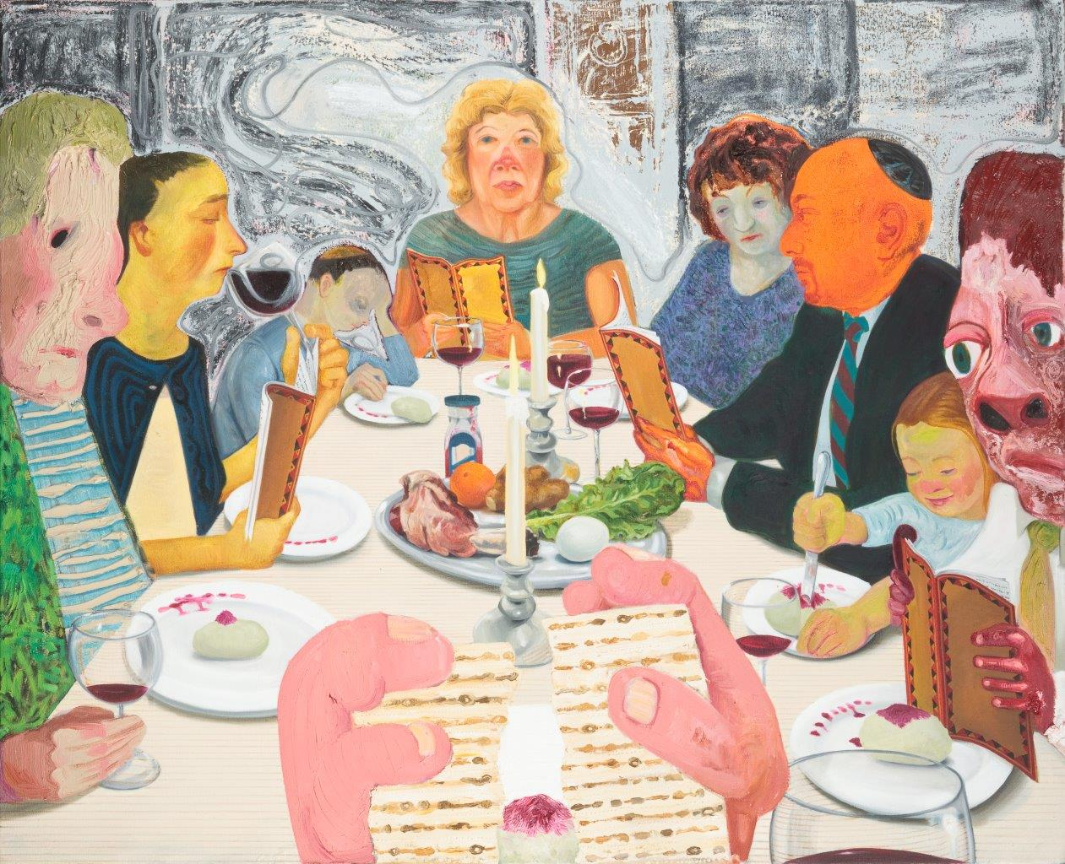

Nicole Eisenman
born 1965, USA

Seder
2010
Oil on canvas
99.2 x 121.9 cm

Lender: The Jewish Museum, New York
Inventory no.: 2011-3
Image: Courtesy the artist and Hauser & Wirth. Photo: Jens Ziehe © Nicole Eisenman
Created: New York

Provenance: Acquired from the artist by The Jewish Museum, New York in 2011 with support from Lore Ross Bequest; Milton and Miriam Handler Endowment Fund; and Fine Arts Acquisitions Committee Fund
https://thejewishmuseum.org/collection/33792-seder

Brief description: Oil on canvas painting of a contemporary Passover meal

Ownership between 1933-1945: NA

List of objects proposed for protection under Part 6 of the Tribunals, Courts and Enforcement Act 2007 (protection of cultural objects on loan).

The following works are proposed to be covered by Immunity from Seizure - from the collection of The Museum of Modern Art, New York.

Nicole Eisenman: What Happened
Whitechapel Gallery
10 October 2023 – 14 January 2024
Galleries 1, 8 and 9

The Museum of Modern Art
11 W 53rd Street, New York
NY 10019
USA
www.moma.org

Whitechapel Gallery
77-82 Whitechapel High Street
London E1 7QX
United Kingdom
T: +44 (0) 20 7522 7888
www.whitechapelgallery.org

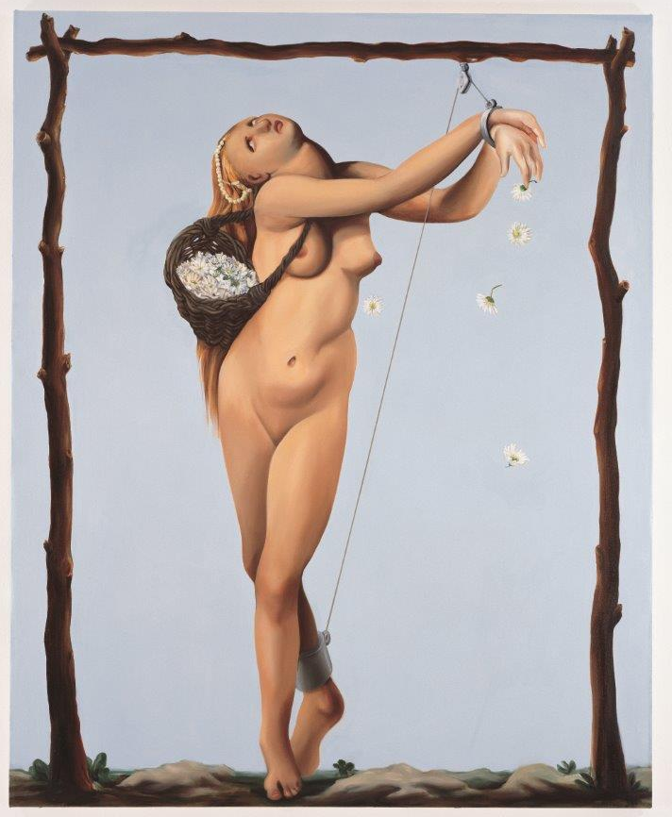
Nicole Eisenman
born 1965, USA

Spring Fling
1996
Oil on canvas
165.1 × 133.4 cm

Lender: The Museum of Modern Art
Inventory no.: 252.2021
Image: The Museum of Modern Art, New York. Gift of Martin and Rebecca Eisenberg in memory of Jack Tilton, 2021. Image courtesy Carnegie Museum of Art. Photo: Bryan Conley
Created: New York

Provenance: Donated to The Museum of Modern Art in 2021 by Martin and Rebecca Eisenberg.

Brief description: Oil on canvas painting of a female figure

Ownership between 1933-1945: NA

The following works are proposed to be covered by Immunity from Seizure - from the collection of The Whitney Museum of American Art, New York.

Nicole Eisenman: What Happened
Whitechapel Gallery
10 October 2023 – 14 January 2024
Galleries 1, 8 and 9

The Whitney Museum of American Art
99 Gansevoort Street
New York
NY 10014
USA
https://whitney.org

Whitechapel Gallery
77-82 Whitechapel High Street
London E1 7QX
United Kingdom
T: +44 (0) 20 7522 7888
www.whitechapelgallery.org

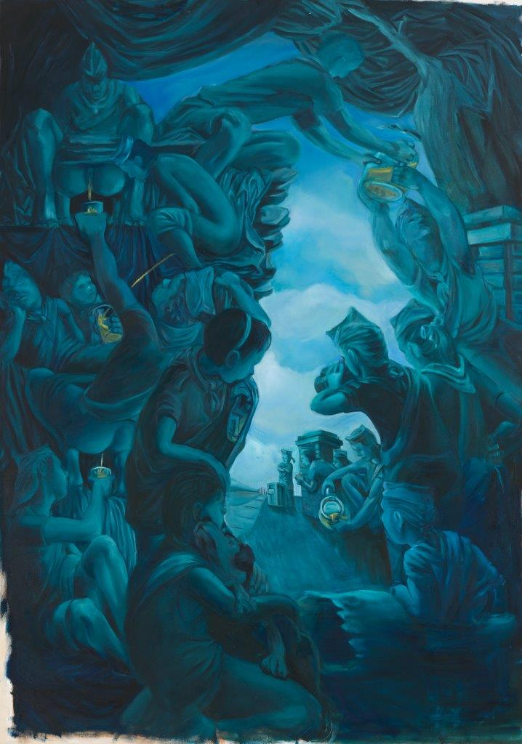

Nicole Eisenman
born 1965, USA

Lemonade Stand
1994
Acrylic on canvas
231.1 x 162.9 cm

Lender: Whitney Museum of American Art
Inventory no.: 94.66
Image: Whitney Museum of American Art, New York; purchase, with funds from Joanne Leonhardt Cassullo © Nicole Eisenman
Created: New York

Provenance: Acquired by The Whitney Museum of American Art, New York in 1994 with funds from Joanne Leonhardt Cassullo
https://whitney.org/collection/works/9024

Brief description: Acrylic on canvas painting of a group figurative scene in blue tones

Ownership between 1933-1945: NA

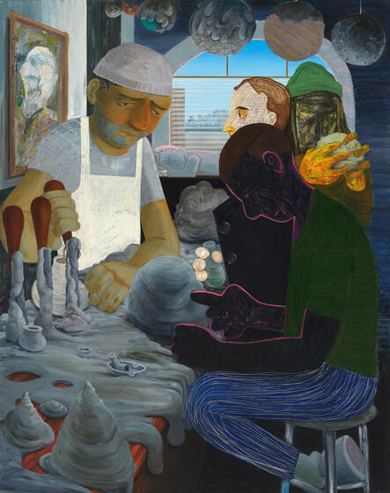

Nicole Eisenman
born 1965, USA

Achilles Heel
2014
Oil on canvas
208.3 x 165.7 cm

Lender: Whitney Museum of American Art
Inventory no.: 2015.55
Image: Courtesy the artist and Hauser & Wirth. Photo: John Berens Photography, Brooklyn, New York © Nicole Eisenman
Created: New York

Provenance: Donated to The Whitney Museum of American Art, New York in 2015 by Andrew and Christine Hall
https://whitney.org/collection/works/46314

Brief description: Oil on canvas painting of figures sculpting clay in the interior of a bar

Ownership between 1933-1945: NA

